DSKY Instructions & User’s Guide

The Apollo guidance computer (AGC) was conceived as a digital solution for a real-time user interface to the pilot. At the supervision of Charles S. Draper, development commenced in 1961 at the MIT Instrumentation laboratory. Up until that time computer instructions we’re fed via punch cards – much similar that of today’s airline ticket. The problem was two-fold:

- Design a real-time user interface that took user input and translate into instructions.
- Engineer a computer small and lightweight enough to fit in a spacecraft.

For its time, the task seemed impossible – even the smallest computers fit in entire rooms and the concept of software engineering was an unknown. Adding to the problem was having the computer perform input/output (I/O) tasks with the computer such as manual control signals, navigation coordinates, radar data and communications. The solution engineered by Hal Lanning was extraordinary and it is the foundation of modern computing: Pre-emptive multitasking - or for the AGC, Job Priority.

For the purposes of understanding how this software works, it is instructive to illustrate how the Display & Keyboard (DSKY) works. At its fundamental operation, the DSKY uses a Prog(ram) (P), Verb (V), Noun (N) to allow the pilot to communicate with the AGC.

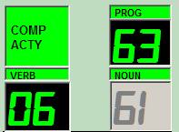
Figure1.1 PROG, VERB, NOUN

Although primitive, this is remarkably similar to how we do computing today. Consider using Microsoft Word:

PROG 63 = Microsoft Word (Run a program)
VERB 06 = Print (Do something)
NOUN 61 = Print what? (Specify File)

In every aspect of modern computing with menus, programs and actions within it can be expressed with the PROG, VERB and NOUN that was engineered at the Instrumentation Lab. In fact, the AGC and its DSKY interface can be considered the world’s first personal computer.

AGC PP. 82-83 Program execution is a simulation of the COUNT, COMPARE, SKIP (CCS) that the AGC employed.

CCS combines many of the requirements for controlling program loops into a single instruction. In this software simulation, the single instruction is the PRO key which evaluates the P, V, N requirements. It then executes the instruction into its own loop. Within these loops a DO, UNTIL, LOOP increments or decrements all 3 registers during execution. The V, N, PRO sequence terminates when ONE of the registers achieves a pre-determined value: DO UNTIL (D_REG_1 = 0). Once the CCS terminates, KEY REL illuminates. The pilot (user) presses KEY REL to begin the next P, V, N sequence.
Using the AGC Software

It is assumed that the user of this software has a remedial background in Computer Science and Zero G avionics including three-dimensional vectors.

The AGC software is divided between two components: On the left, a faithful reproduction of the actual DSKY interface that the pilots used. On the right are controls and displays required within the landing procedures. It is not a representation of the actual Lunar Module but it fulfills the requirements of a software-only Lunar Landing and Ascent simulator.

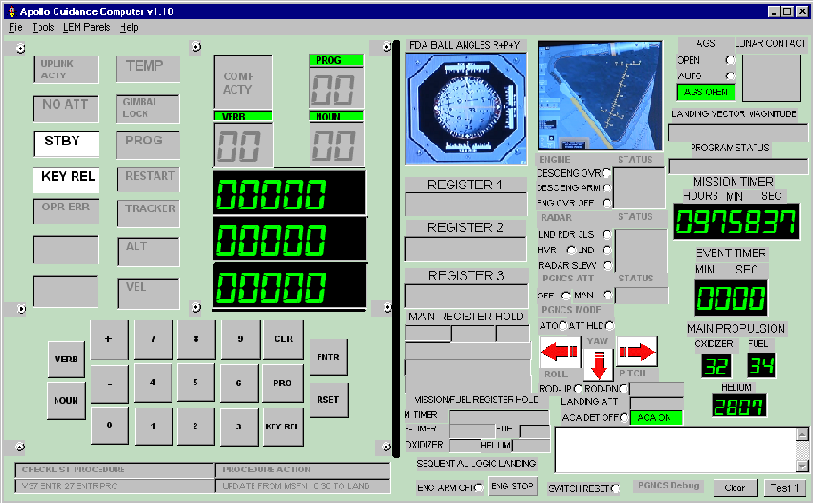
Left Pane DSKY Right Pane: Controls and Displays

Figure 1.2 AGC DSKY Software Layout

Within the controls and displays pane are the various click-able objects that are outlined in the landing instructions. At right are registers that monitor the mission and event timers. Below that are the main propulsion registers that decrement during each procedure execution relevant to fuel consumption. At the top right is the lunar contact light that illuminates upon lunar landing.

The fundamental operation of the DSKY relies on procedures and sequential logic. In addition to the sequential logic outlined in this document, there are two ways to access the landing procedures for the AGC.

- On the menu go to Tools> Lunar Landing Cue Card. A window will appear “PDI Rules/Altitude Check” This window can be left open during DSKY operation and describes in detail each step to be taken.

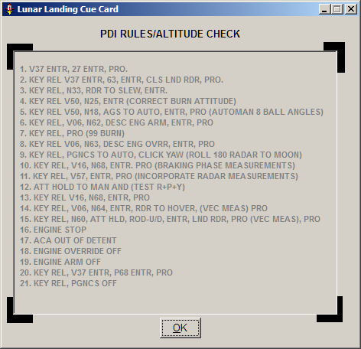
Figure1.3 PDI/Altitude Rules Check

- At the bottom of the DSKY pane are two status panels that instruct the Pilot (User) what the exact next step to take after the current procedure has completed. When the DSKY starts, it displays the first program to run by default.

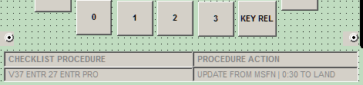
Figure 1.4 Sequential Logic /Status Bar at Startup

DSKY Controls and Features
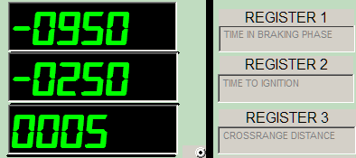
Figure 1.5 Main DSKY REGISTERS

Registers – There are 3 primary registers dedicated to monitoring and changing spacecraft operations and navigation. These registers are directly below the PROG, VERB, NOUN fields. To the right of these registers are the action(s) the AGC is performing.

Keys - As implied, the DSKY is comprised of a numerical keyboard along with action keys. These keys consist of VERB, NOUN, ENTR and PRO. Of these, during normal AGC operation the following keys are explained:

KEY REL - This is the most important key on the DSKY. Depending on what needs to be done, it will either change programs or tell the DSKY what VERB, NOUN the current program expects.

VERB – Working closely in sequence with the KEY REL, after pressing KEY REL, the VERB key will then be expected to enter either a command to change programs or simply a VERB under the current PROG to set the field into NOUN to enter what the current program is instructed to do.

ENTR – After the pilot enters the P,V,N commands, ENTR is pressed. In most situations the data registers will update with the correct parameters. If these are acceptable, the Pilot presses the PRO key to execute the maneuver.

The common VERBS and NOUNS described as follows:

VERBS
V06 – Display as decimal in R1 or R2 or R3
V16 – Monitor decimal in R1 or R2 or R3
V50 – Please perform
V37 – Change program

NOUNS
N68 – Displays flight status in ROLL + PITCH + YAW
N63 – Displays altitude between AGC and radars

AGC and DSKY Error Handling

If the procedures aren’t followed accurately, an error will occur and the pilot must correct it. In most cases, a dialog will appear notifying the pilot of the error and the action required to correct it. In keeping with the spirit of the original flight computer the pilot might generate an OP ERR light in the event the wrong combination of P,V,N is entered.

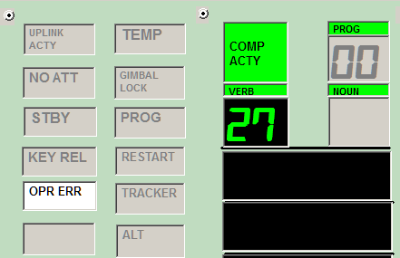

This can only be corrected by pressing the RSET key. This will attempt to restore the AGC to the last known good state using the MAIN HOLD REGISTERS and MISSION/TIMER hold registers. Unfortunately, just like the original AGC, the RSET does not correct more serious errors and a master reset may be necessary. This can be accomplished in two ways

- Go to File> Mater Reset
- If possible, Press KEY REL, Key V37, P06, ENTR.

A reset can be performed simply by closing and re-opening the software. One of the more challenging aspects for the pilots was correcting the error using the DSKY itself. Obviously, the Pilots couldn’t close the window and re-open again.

With a less serious error, the pilot can try to press the CLR key to clear the VERB, NOUN field and resume without a RSET. If the pilot recognizes a VERB or NOUN entry error before pressing the ENTR key, simply pressing the VERB or NOUN key again will allow the pilot to correct the error by simply re-entering the correct VERB or NOUN.

Debugging
This software has been tested ad debugged to exhaustion. Due to the design and sequential logic requirements to simulate the original flight-ready AGC, there is still the possibility of bugs to emerge during operation – especially if the landing sequence isn’t followed with precision. Because this software uses CCS looping routines, it is possible for the pilot (user) to get caught in an infinite loop. In this event there are two options for recovery.

- Allow the loop to execute until the fuel reaches 12%. The program will terminate with a null pointer exception
- Use the CTRL+ALT+DEL windows tak manager to terminate the application

